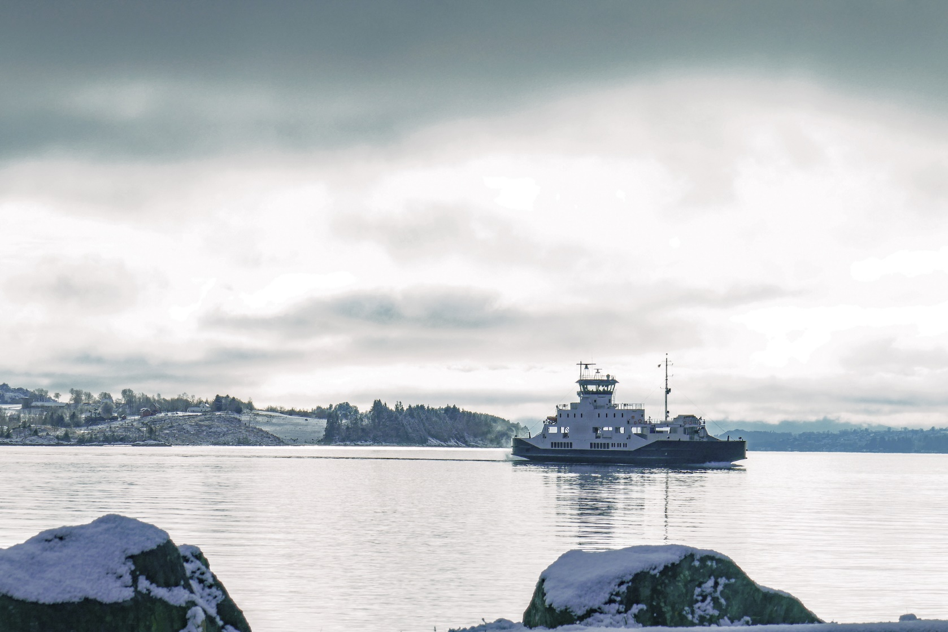
Summary
COST OF TRANSITIONing TO FOSSIL-FREE public TRANSPORT

Øyvind N. Handberg, Rolf Hagman, Annegrete Bruvoll, Tale Ørving, Siri Voll Dombu and Heidi Ulstein

Front page picture: MF Folgefonn, in traffic at Jektavik-Nordhuglo-Hodnanes.

Summary
The Norwegian Government has set at target to reduce emissions from the transport sector by 50 percent in 2030 compared with 2005. As responsible for public transport (except trains and national roads), the municipal sector plays an important role in reducing greenhouse gas emissions. Based on interviews with all counties, this project analyses the plans of phasing in fossil-free solutions in public bus, boats and ferry traffic. We estimate the cost of the investments in emission free technologies so far, planned investments, and cost related to a potential total phase-out of fossil fuels in the future.
We estimate that 23 per cent of the present municipal bus traffic is already operating fossil-free, and that this share will rise to almost 50 per cent by 2021, given the investments that are already planned. Electric buses are common in urban areas, and costs are expected to fall together with further phasing-in towards 2025. Outside cities, counties tend to focus on biogas (biomethane) and renewable diesel fuels (largely HVO). Around 75 per cent of the fossil-free traffic work is estimated to be operated with renewable diesel fuels in the period 2019-2025.
There are few electric ferries in operation today. According to approved plans, almost 3 million annual kilometres of ferry traffic will be operated with electricity instead MGO or LNG, replacing about one third of the total ferry routes. Eight percent of the emission free solutions are already phased in before 2019, while the rest is planned to be implemented before 2025. Hordaland and Møre og Romsdal stand out among the counties, as they have decided to electrify 17 and nine ferry connections, respectively, over the next few years. This represents 83 per cent of the planned electric free kilometres in Norway. Except city boat connections in Bergen and Oslo, only two municipal speedboats are approved for piloting of fossil free traffic in Norway.
Figure A Estimated annual reductions in greenhouse gas emissions (tCO2e), by means of transport

Figure A shows the estimated annual reductions in greenhouse gas emissions from county transport as a result of the phasing-in of fossil-free solutions. In 2019, the estimated effect is about 160,000 tonnes of CO₂-e per year, mainly as a result of conversion to renewable diesel fuel and biogas in bus traffic (81 per cent). The estimated reduction in 2025 is about 250,000 tonnes of CO₂-e per year. As of 2020, we estimate that electrical solutions will contribute 43-45 per cent of the annual emissions reductions from the sector, mainly as a result of electrification of ferry services.
This contribution to reach national emission targets implies additional costs for the counties, as the costs would have been lower with conventional solutions with mineral oil and natural gas as energy carriers. Figure B shows the counties’ estimated annual additional costs for implemented and decided investments in infrastructure, procurement or rebuilding of vessels/vehicles and potential increased operating costs for bus, ferry and boat traffic. In particular, the figure shows the large increase in additional costs related to ferry electrification, carried by a few counties. The counties’ total additional costs are estimated at almost NOK 645 million per year by 2025. This is equivalent to an additional cost of about NOK 2600 per tonne of CO₂-e that accrues to the counties.
Figure B Estimated annual additional costs for the counties by the phasing-in and decided implementation of fossil-free public transport (mill. NOK, 2019), by means of transport

Figure C presents the estimated additional costs for the counties with the implemented and planned transition fossil-free solutions, due to procurement or rebuilding of vessels/vehicles and potential increased operating costs for bus, ferry and boat traffic. Additional costs due to infrastructure investments is thus not included (unlike Figure B). We estimate these additional costs to be just below NOK 500 million per year by 2025.
Figure C Estimated annual additional costs for the counties (infrastructure investments not included) by the phasing-in and decided implementation of fossil-free public transport (mill. NOK, 2019), by means of transport

While Figure B and C indicate the counties additional costs due to the decided upon transition to fossil-free solutions, Figure D shows the Figure D shows the counties' estimated total costs to reduce all greenhouse gas emissions from the transportation under their responsibility. We estimate these costs to be in the range NOK 860-1 340 million by 2030. This estimate includes both additional costs already incurred and future additional costs for the cutting the remaining emissions. The span results from uncertainty in technological and economic maturity. The high estimate is based on the fossil solutions being converted to the most expensive technology, while the low estimate is based on the lowest cost estimates.
Figure D Estimated annual additional costs (mill. NOK, 2019) by transitioning to fossil-free county municipal public transport - high and low estimates, 2019-2030

The estimates of future additional costs for not-determined investments does not consider potential financial support from Enova's support schemes. If financial support is given, the counties' investment costs will be somewhat lower. The additional costs associated with the purchase of vessels and vehicles and for operation will however mainly be paid for by the counties. For the already phased-in and decided upon investments, the Enova support amounts to 20 and 30 percent of the total additional costs, within bus and ferry respectively.
There is considerably uncertainty in the cost estimates. In particular, the costs of necessary grid upgrades and other infrastructure investments (such as battery banks) are uncertain. The counties express concern about how to cover these additional costs. For not yet approved investments, there is uncertainty related to technological maturity. The projections in figure D also assume that the additional costs are constant throughout each contract period. With more flexible contracts and falling costs, the additional costs can be lower.



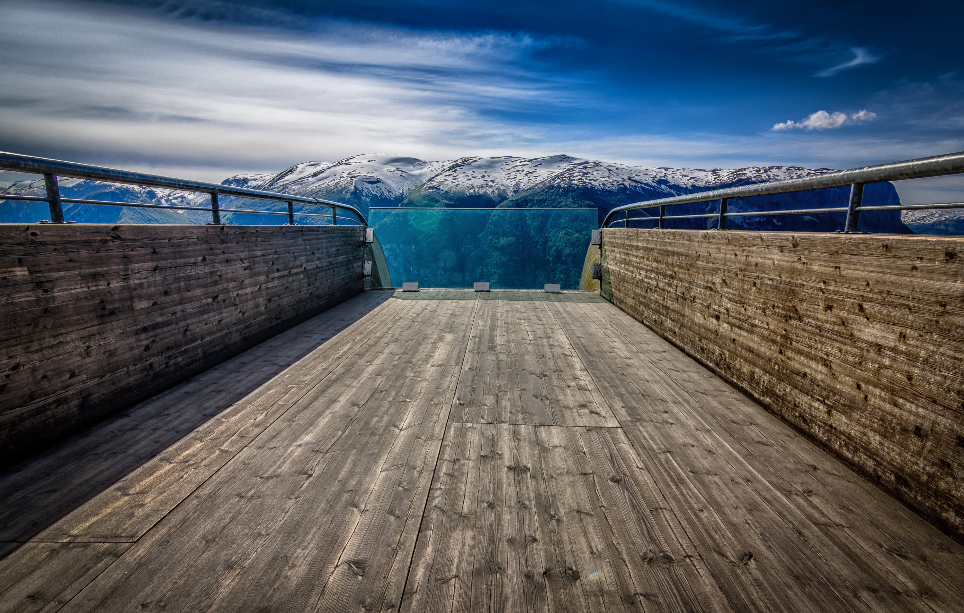
T
+47 909 90 102 | post@menon.no | Sørkedalsveien 10 B, 0369 Oslo | menon.no
Menon Economics analyserer økonomiske problemstillinger og gir råd til bedrifter, organisasjoner og myndigheter.
Vi er et medarbeidereiet konsulentselskap som opererer i grenseflatene mellom økonomi, politikk og marked.
Menon kombinerer samfunns- og bedriftsøkonomisk kompetanse innenfor fagfelt som samfunnsøkonomisk
lønnsomhet, verdsetting, nærings- og konkurranseøkonomi, strategi, finans og organisasjonsdesign. Vi benytter forskningsbaserte metoder i våre analyser og jobber tett med ledende akademiske miljøer innenfor de fleste
fagfelt. Alle offentlige rapporter fra Menon er tilgjengelige på vår hjemmeside www.menon.no.

